This is a Sample Title for Your Paper [12pt Arial Font, Title Case - Major Words are Capitalized, and Most Minor Words are Lowercase)*]
(2 lines spacing here - with a leading (interline spacing) of 10pt)
First Author⁽¹⁾, Second Author⁽²⁾ and Third Author⁽³⁾ (Full Name, 10pt Arial Font; separated by commas)
(1 line spacing here leading (interline spacing) of 10pt and no spacing before and after)
^{(1,3)} Affiliation Institution 1, City, Country, (ACRONYMS IN INSTITUTION NAMES AND FULL ADDRESS ARE NOT RECOMMENDED)
e-mail (Use “Arial” font, size 8pt)
⁽²⁾ Affiliation Institution 2, City, Country,
e-mail (Use “Arial” font, size 8pt)
(2 lines spacing here)

Abstract [10pt Arial Font, Sentence case, bold]
(1 line spacing here)
The abstract [in one paragraph of 250 words or less; not indented -only justified-,10pt Arial font] should state briefly the purpose of the research, the essential new information, the principal results and major conclusions. The abstract must be able to stand-alone and references to the manuscript should therefore be avoided.
(1 line spacing here)
Keywords: Please list a maximum of 5 keywords [10pt Arial font, separated by; semi-colons, first letter of first word of each keyword capitalized, space between the keywords]
(2 lines spacing here)

- INTRODUCTION [10PT ARIAL FONT, UPPERCASE, BOLD]
(1 line spacing here)
This document contains a detailed guideline for the papers of the 39th IAHR World Congress 2022. The paper´s length is 4 – 10 pages including texts, figures, tables and references. This is an example of the final manuscript. The various components of your paper [title, text, heads, etc.] are already defined on the style sheet, as illustrated by the portions given in this document. These instructions serve as an example for proper manuscript production. The figures can be in color since the paper is published online. [Note: No spacing between paragraphs.]
Please follow the format described here and demonstrated by example with regard to placement of paper title, length and width of text. Do not add any kind of pagination anywhere in the paper.
All standard paper components have been specified for three reasons: ease of use when formatting individual papers, automatic compliance to electronic requirements that facilitate the concurrent or later production of electronic products, and conformity of style throughout the paper. Margins, column width, line spacing, and type styles are built-in; examples of the type styles are provided throughout this document and are identified in red boldface, within square brackets, following the example.
You can delete this sample text and replace it with the text of your paper. However please note that papers must strictly follow this sample, and therefore we strongly recommend you that you keep an initial version of this file for reference.
First, confirm that you have the correct template for your paper size. Please use A4 size paper, in one column format with “Arial” font. Margins are as follows Top: 1.2cm; Bottom: 1.6cm; Left: 2.0cm; and Right: 1.8cm. Header is at 1.2cm and Footer at 1cm from the page limit, respectively.
The template is used to format your paper and style the text. All margins, column width, line spaces, and text fonts are prescribed; please do not change them. All the paragraphs are indented and justified, except for the abstract -only justified-.
(1 line spacing here)
- HEADINGS AND BODY OF TEXT [10pt ARIAL FONT, UPPERCASE, BOLD]
(1 line spacing here)
The Heading 1 should be set in 10pt Arial boldface, bold, uppercase with a leading (interline spacing) of 10pt and a single spacing of respectively, before and after
(1 line spacing here)

  - First Level Headings [10pt Arial, regular face and title case]
(1 line spacing between first level heading and text)
The third level headings should in 10pt “Arial” italic face, with a leading (interline spacing) of 12pt and a spacing of 6pt before and after.

  - Body of Texts
The normal texts should be set in 10pt “Arial” with a leading (interline spacing) of 10pt and a single spacing. Lines are single-spaced. The paragraphs should be justified at left and right margins of the text.

- USING THE TEMPLATE FOR SEVERAL COMPONENTS (10pt ARIAL, UPPERCASE, BOLD)

  - Equations

Equations should be centered and numbered consecutively, as in Eq. [1]. An alternative method is given in Eq. [2] for long sets of equations where only one referencing equation number is wanted.
(1 line spacing here)
 |  | [1]
where, | (1 line spacing here)
 |  | [2]
(1 line spacing here)
  - List

Lists can be provided using either numbers or bullets:
- List item 1 like this;
- List item 2 is an example of a longer list item that wraps to a second line, where the second line is indented.
The example for bulleted items like this:
- List item 1;
- List item 2.

  - Tables and figures

Tables and figures should appear in one column of a page and be numbered consecutively. Figures and texts may appear on the same page, and a centered caption should appear directly beneath the figure. It is preferable that figures be mounted in portrait style and figure captions are no longer than two lines. On figures showing graphs, both axes must be clearly labeled (including units if applicable).
Tables should be designed to have a uniform style throughout the paper, following the style shown in Table 1. Table captions should be in 10pt Arial bold, centered, and the texts in Table should be set in 9pt Arial font.

Table 1. Caption heading for a table should be placed at the top of the table and within table width. [Table 1,2, etc in bold; regular face for the caption, 10pt Arial Font, Centered, No spacing after table title]
 | A | B | C | D
A | Aa | Ab | Ac | Ad
B | Ba | Bb | Bc | Bd
C | Ca | Cb | Cc | Cd
D | Da | Db | Dc | Dd
E | Ea | Eb | Ec | Ed
[1 line spacing here]
Authors are advised to prepare their figures in either black and white or color. Please prepare the figures in high resolution (300 dpi) for half-tone illustrations or images. Pictures must be sharp enough otherwise they will be rejected. Figures must be originals, computer-generated or drafted, and placed within the text area where they are discussed. Figure 1 shows one example. [Figure captions should be in 10pt Arial, centered. When applicable, the texts in graphs, illustrations or images should be set in 8pt Arial]
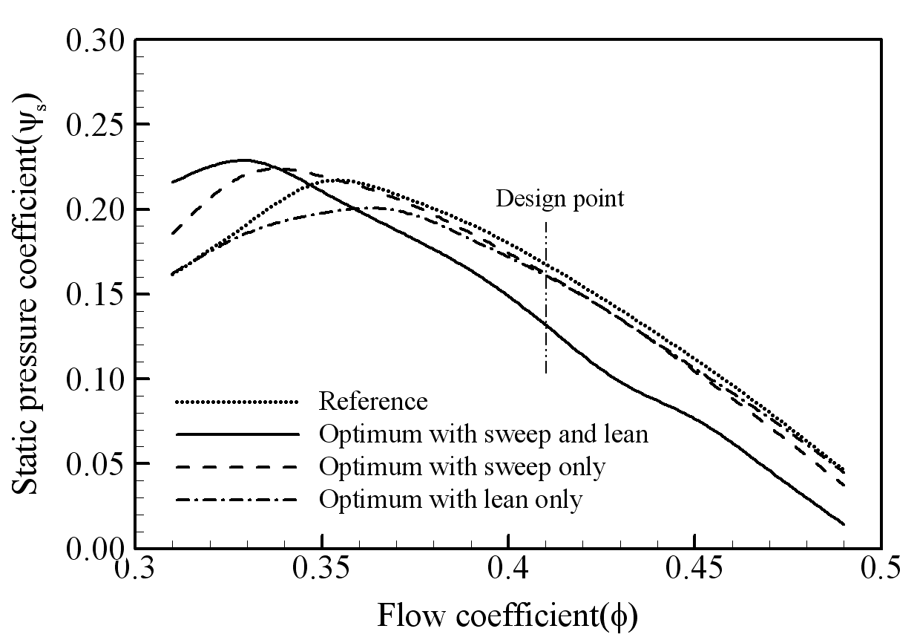
Figure 1. The caption heading for a figure should be placed below the figure and within figure/illustration width. [Figure 1, 2 etc. in bold, regular face for the caption. 10pt Arial font, no spacing between title and figure]

  - Footnotes

Footnotes are denoted by a character superscript in the text b.

  - Units

Use either SI (MKS) as primary units. English or CGS units may be used as secondary units (in parentheses). Avoid combining SI and CGS units. This often leads to confusion because equations do not balance dimensionally. If you must use mixed units, clearly state the units for each quantity that you use in an equation. Do not mix complete spellings and abbreviations of units. Spell out units when they appear in text.

- CONCLUSIONS [10pt ARIAL FONT, UPPERCASE, BOLD]

If the formatter still needs to create a component which is not prescribed here, please incorporate applicable criteria that follow the styles provided (e.g., spacing and typeface).

- ACKNOWLEDGEMENTS [10pt ARIAL FONT, UPPERCASE, BOLD]

This is where one acknowledges funding bodies, etc.
We appreciate the cooperation and efforts of all authors in producing the Proceedings. This will be a great congress following the tradition of our sponsoring organizations.

- REFERENCES [10pt ARIAL FONT, UPPERCASE, BOLD]

References should appear together at the end of the paper, listed alphabetically by last name of the first author. Thereafter sorting is made by co-authors and year. However, in the text, sorting is done by year (Don et al., 2005; Gran, 1992). References in the text consist of the author name and publication year in parentheses, as found in Don et al. (2005). If several references are cited collectively, they are enclosed on parentheses with no additional parentheses around dates. All references listed should be cited in the text. Example reference citations are provided at the end of this paper. Here are examples:

Dong, N.C.(note: no spacing between alphabets), Araki, H., Yamanishi, H., and Koga, K. (2005). Simulation of groundwater flow and environmental effects resulting from pumping. Environmental Geology, 47 (3), 361-374.
Donelan, M.A. (1978). Whitecaps and momentum transfer. NATO Conf. on Turbulent fluxes through the sea surface, wave dynamics, and prediction, Ed. A. Favre and K. Hasselmann, Plenum, NY, 273-287.
Gran, S. (1992). A course in ocean engineering. Elsevier, 583 pp.
Hwang, P.A., Hsu, Y.H.L. and Wu, J. (1990). Air bubbles produced by breaking wind waves: a laboratory study. J. Phys. Oceanography, 20, 19-28.

b Just like this one. * major words: Nouns, verbs (including linking verbs), adjectives, adverbs, pronouns, and all words of four letters or more are considered major words.minor words: Short (i.e., three letters or fewer) conjunctions, short prepositions, and all articles are considered minor words.

